Address: 7140 E 46th St
Docket # Original Petition 23-LSE-08
Approval Petition 25-LAP-01
Hearing Date: February 18, 2025
Council District # #1 (Giles)

Petitioner: Loriane Hogue-Jackson
4619 Thornleigh Dr
Indianapolis, IN 46226
317-450-1954
Greatanswers4u@gmail.com

Owner: Proparity Real Estate LLC
1910 E Washington St
Indianapolis, IN 46201
317-640-3360
skline@klinepm.com

Application:
A Special Exception Variance of Use of Table 743-1 to allow Transitional Living Quarters in a C-4 zone (not allowed) was approved November 21, 2023 with the requirement that the petitioner come before the Board one year later to reevaluate the approval.

Summary of the Subject Property Zoning Standards
Current Zoning Designation: | C4
Surrounding Property Zoning
North: | D5
South: | C4
East: | C4
West: | C4
Comprehensive Plan Land Use Designation: | Suburban Neighborhood ~
Current Land Use: | Commercial
Compact Context Area: | Metro
Relevant Code Sections: | Table 743-1

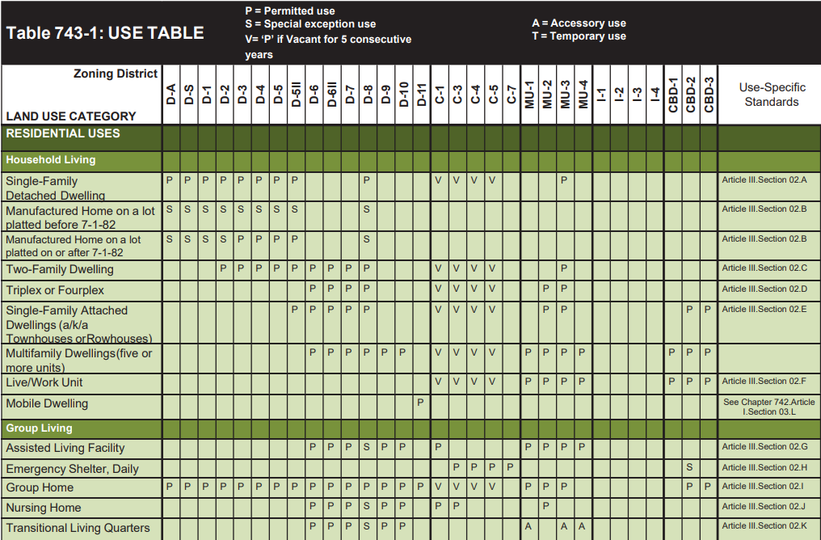

Aerial:
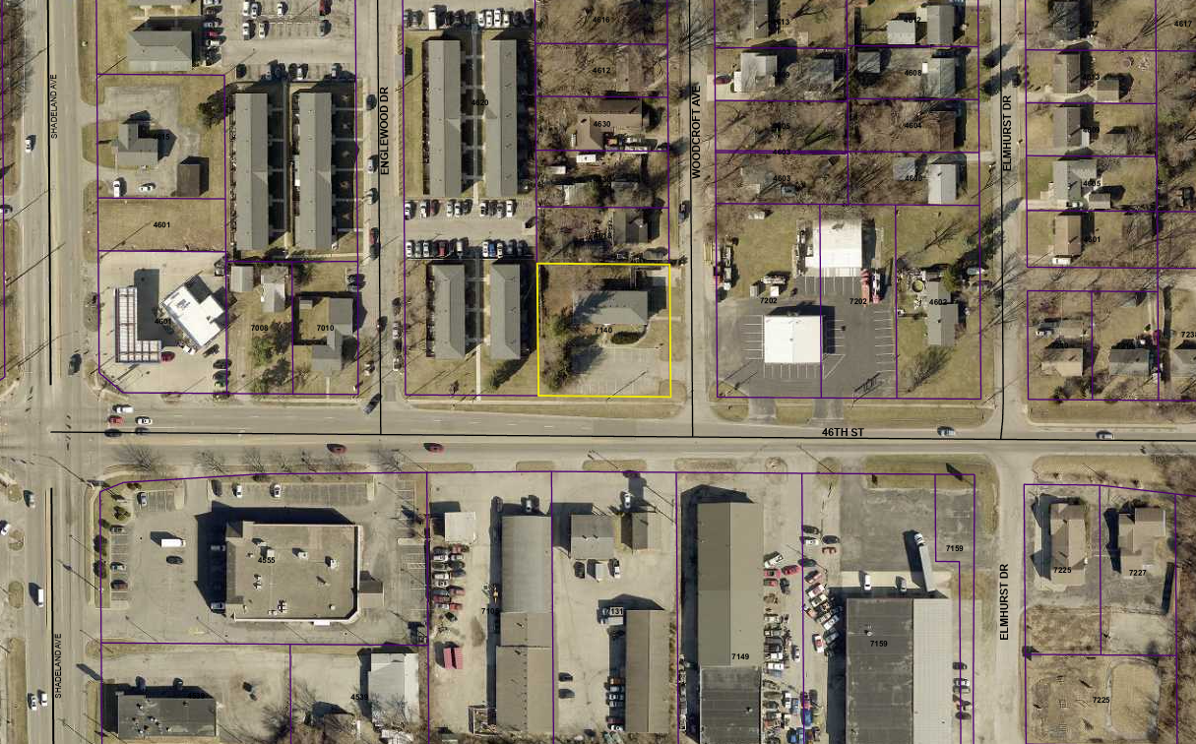

Zoning Base Map:
